

**Car Pooling Application**

**Software Requirement Specification (SRS) Document**

**Sprint 1 Implementation**

**Project Timeline: 20.10.2022 to 27.10.2022**

**INDEX**

**1. Introduction**

1.1 Purpose ------------------------------------------------ 4

1.2 Intended audience ------------------------------------------------- 4

1.3 Intended use ------------------------------------------------- 4

1.4 Scope ------------------------------------------------- 4

**2. Overall description** ------------------------------------------------ 5

2.1 Assumptions and dependency --------------------------------------------- 5

**3. System feature and requirements** ------------------------------------------------ 6

3.1 Functionality ------------------------------------------------- 6

3.1.1 Main Menu --------------------------------------- 6

3.1.2 Registration_process --------------------------------------------- 6

3.1.3 Changing_transporter_personal_details ----------------------------------- 6

3.1.4 Commutor_registration_processs ------------------------------- 6

3.1.5 Registered_commutor_service ----------------------------------- 6

3.1.6 Editing_commutor_details ------------------------------------------- 7

3.1.7 Requesting_admin ------------------------------------- 7

3.1.8 Admin_edit_transporter_and_commutor_data --------------------------- 7

3.1.9 Report_on_vehicles -----------------------------7

3.1.10 Report_on_busiest_routes ------------------------------7

3.2 System requirement -------------------------------------------------- 8

3.2.1 Tools to be used ------------------------------------- 8

3.3 System feature --------------------------------------------8

**4. Data Flow Diagram**

4.1 DFD level 0 ------------------------------------------------ 9

4.2 DFD level 1 ------------------------------------------------ 10

### **1.** **Introduction: -**

The introduction of the software requirement specification provides an overview of the entire software. The entire SRS with overview description purpose, scope, tools used and basic description. The aim of this document is to gather, analyze and give an in-depth insight into the complete Car pooling application by defining the problem statement in detail. The detailed requirements of the Car Pooling application is provided in this document.

* 1. **Purpose**: **-**

The purpose of this document is to show the requirements for the Car Pooling application, in which people share rides with other people and save money after every rides, their rides will be updated in the records. Carpooling allows you to share the cost of gas and parking also help to reduce air pollution and traffic , Cutting your expenses by nearly 50% or more the more occupants in your carpool the more you save. Carpooling is also socially economically.

**1.2 Intended Audience: -**This document is intended to be read by Commuter.

**1.3 Intended Use: -**

* Development Team
* Transporter Team
* Commuter

Since this a general -Purpose Software any one can access it.

**1.4 Scope: -**

The goal of this project is to construct the CarPooling application. It is a very effective method of reducing pollution and car traffic in cities. It also provides an environmentally beneficial mode of transportation. It also gives you the opportunity to meet new individuals. Because of the delays created by public transportation and the comforts given by private vehicles, most individuals today choose to travel by private vehicle. Pre-registration ensures security by allowing only verified individuals to enter the vehicle, allowing trust to be formed. People who have registered can be assigned specified days to use their private vehicle so that its registered passengers are not inconvenienced on their everyday trip. As a result, the suggested carpooling system will be successful in decreasing pollution to the environment.

**2. Overall Description: -**

Car Pooling is a vehicle-finding application in which drivers who are driving alone to work can ask for passengers, and people who use public transportation to get to work every day can use this system to meet drivers who are traveling to the same place in a short path. This project enables users to access mobility assets owned by others at the specific moment they desire them.Carpooling (also known as car-sharing, ride-sharing, and lift-sharing) is the practice of sharing vehicle journeys such that more than one person travels in a car, reducing the need for others to drive to a site individually. Carpooling often involves sharing the travel costs equally among all car occupants. People who work in areas with more employment nearby and live in areas with higher residential populations are more likely to carpool. Carpooling is strongly connected to vehicle maintenance expenses, such as fuels prices and travel length.

Carpooling decreases each person's travel costs such as gasoline, tolls, and the stress of driving by having many people use one vehicle. Carpooling is also a more economically beneficial and sustainable mode of transportation because it decreases air pollution, carbon emissions, road traffic congestion, and the demand for parking places.

**2.1 Assumptions and Dependency : -**

* System should have Ubuntu Linux installed.
* System should have either 4GB or more RAM.
* The service is used preferably on a desktop or laptop.

**3. System Features and Requirements: -**

**3.1 Functionality: -**

**3.1.1 cp_01**-> **main menu**

This is the first main menu level function that provides flexibility to enable the commuter and transporter to register using Aadhar card and personal details. Here user can also select the type of module that the commuter and transporter wants to open.

**3.1.2 cp_02-> Registration_process**:

* The person who wants to provide the transport service, is required to register on the system with his Driving License no(dlno) and personal details. Let’s call him the transporter. Routes in the city are already named as point A, Point B etc. 6 such points are alphabetically available.
* The transporter need to provide a source and a destination point. his vehicle type, no. Of commutors it can carry and ac/no ac etc. Also he need to specify the distance in km., between the two points.Charges per km should not exceed Rs. 5/- per day.Once the registration is done successfully the transporter is provided with a unique-id which is generated by the system.

**3.1.3 cp_03-> Changing_transporter_personal_details:**

The transporter is allowed to change his personal details but once registered he cannot change the route. Upon his request the admin can do that.

**3.1.4 cp_04->Commuter_registration_process:**

The commuter need to register using his unique aadhar no and other personal details.

**3.1.5 cp_05-> Registered_commutor_service:**

A registered commutor can enquire about the service after registration. He will have to enter his aadhar no. After that he will be asked for his source and destination. He will be displayed with a list of vehicles available for the route. On selecting one vehicle he will be shown the monthly charge for the same. He need to confirm his registration for the service by paying 10% of the total monthly cost for the service.

**3.1.06 cp_06-> Editing_commutor_details**:

The commutor is also allowed to change his personal details.

**3.1.07 cp_07-> Requesting_admin**

He can choose to discontinue the service, in that case he need to make a

request to the admin, who will delete his details.

**3.1.08 cp_08-> Admin_edit_transporter_and_commutor_data**

The admin can add, modify or delete the transporter data. Also the admin can add, modify or delete the commuter data.

**3.1.09 cp_09-> Report_on_vehicles**

A report containing details of all vehicles for all routes along with respective

transporter name should be available.

**3.1.10 cp_10->Report_on_busiest_routes**:

A report to show the details of the busiest route in terms of. No of commuters

registered for the same is also available.

**3.2 System Requirements: -**

### **3.2.1. Tools to be used:**

* C File Handling
* C Language
* Vi Editor
* Splint
* Valgrind
* makefile

### 3.3 System Features: **-**

### **Supportability:** The device is simple to utilize.to utilize.

* **Design Constraints:** The device is constructed the use of only c language.
* **Reliability & Availability:** The system is accessible 24/7 that's at whatever point the client would like to utilize the system, they can utilize it up to its functionalities.

### **Performance:** The device will work on the  terminal.

**4. Data Flow Diagram:**

**4.1 DFD level 0-**

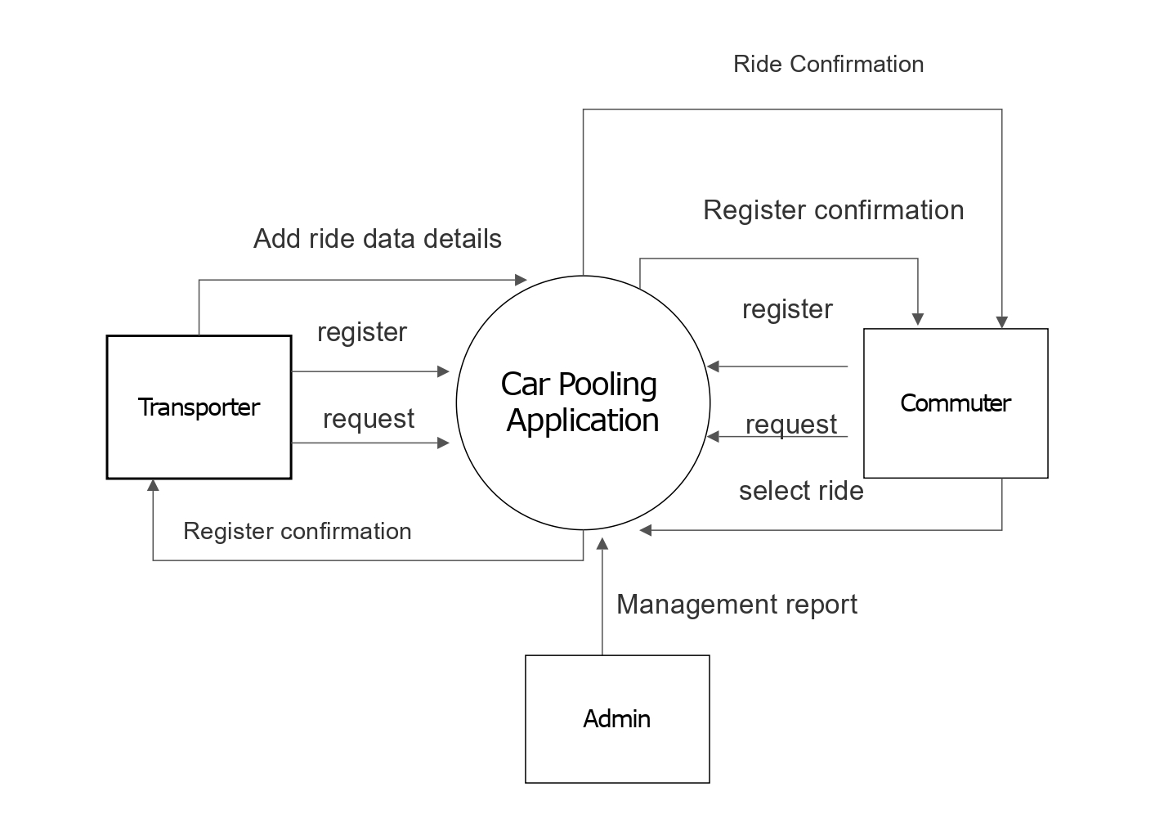

**4.2 DFD Level 1 –**

